DEPARTMENT OF BIOLOGICAL, CHEMICAL, AND PHYSICAL SCIENCE

ILLINOIS INSTITUTE OF TECHNOLOGY

PHYSICS 123

Torque

**Lab 11**

Markiyan Varhola

A20324717

Date of Experiment: Nov. 12, 2015

Due Date: Nov. 19, 2015

Lab Section: 03

Lab Partner: Bhav Bhalla

TA: Shokoufeh Asalzadeh

**Statement of Objective**

The object of this lab was to devise an experiment that would allow for the measurement of the moment of inertia by varying the length of a lever arm. Also, using newton’s second law for rotational motion, the proportional relationship between the angular acceleration and the torque would be verified. The inverse proportionality of the moment of inertia to the angular acceleration of an object would also be verified.

**Theory**

When a force is applied to a body about its axis of rotation, a rotating force called **torque** occurs. The magnitude of the torque can be measured by the cross product of the force acting on a “lever arm”, or a distance away from the axis of rotation.

*Equation 1: Magnitude of the torque*

$τ=r×F=rFsin(θ)$

Using Newton’s second law, the net torque of a system is given via the following equation:

*Equation 2: net torque of a system*

$τ=Iα$

In this equation, $α$ is the angular acceleration about an axis of the force, while I is the moment of inertia. For a point particle of mass m and distance r from the axis of rotation, the moment of inertia is the following:

*Equation 3: moment of inertia*

$I=mr^{2}$

The moment of inertia of a body along another parallel axis can be calculated using the Parallel Axis theorem:

*Equation 4: parallel axis theorem*

$I=Icm+md^{2}$

**Equipment List**

* Bobbin
* Rotating Platform with Masses
* String
* Calipers
* Data Studio Software

**Procedure**

A rotating platform was set up with a bob and wheel system. A bob was attached to a string, which was wrapped over a puller and around a circular part of the rotating platform with a measured radius. For the first part of the experiment, the angular acceleration was measured from by changing the radius of rotation where the string was wrapped around. This was tested with several masses hanging from a bob on the side of the rotating platform. The setup in the second part of the experiment was similar to that of the first, except the masses were kept constant for both of the radii. The distance between the axis of rotation and the balancing masses was recorded, and the angular acceleration that resulted was also recorded.

**Data**

*table 1: Constant Moment of Inertia*

|  |  |  |  |  |
| --- | --- | --- | --- | --- |
| **r (m)** | **m (kg)** | **a (angular)** | **T (torque)** | **I (kgm^2)** |
| 0.0125 | 0.1 | 0.27 | 0.012 | 0.0454 |
| 0.0125 | 0.15 | 0.41 | 0.018 | 0.0449 |
| 0.0125 | 0.2 | 0.56 | 0.025 | 0.0438 |
| 0.018 | 0.1 | 0.429 | 0.018 | 0.0412 |
| 0.018 | 0.15 | 0.652 | 0.026 | 0.0406 |
| 0.018 | 0.2 | 0.888 | 0.035 | 0.0398 |

*table 2: Constant Torque*

|  |  |  |  |  |  |
| --- | --- | --- | --- | --- | --- |
| ***r*** | ***m*** | ***d*** | ***T (torque)*** | ***a (angular)*** | ***I (kgm^2)*** |
| 0.0125 | 0.15 | 0.1 | 0.018 | 0.27 | 0.067 |
| 0.0125 | 0.15 | 0.15 | 0.018 | 0.41 | 0.044 |
| 0.0125 | 0.15 | 0.2 | 0.018 | 0.56 | 0.032 |
| 0.018 | 0.15 | 0.1 | 0.026 | 0.429 | 0.061 |
| 0.018 | 0.15 | 0.15 | 0.026 | 0.652 | 0.04 |
| 0.018 | 0.15 | 0.2 | 0.026 | 0.888 | 0.029 |

**Analysis of Data**

By using the set of equations, the value for the the moment of Inertia was calculated and varied very little. Therefore, this data was used in showing the relationship between the angular acceleration and the torque. The slope of the graph is the moment of inertia.

*Figure 1 and 2: Angular Acceleration vs Torque at different radii*

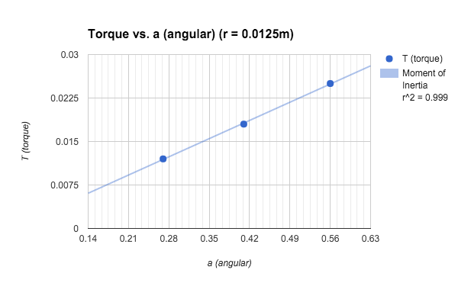

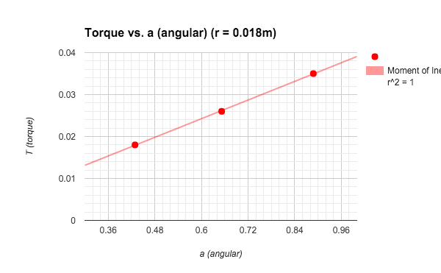

The graphs show a proportional relationship for Torque vs Angular Acceleration. The r^2 value of almost 1 shows that these results are accurate and precise. The slope of the graph represents the moment of inertia, which is constant for both trials.

*Figure 3 and 4: Inverse relationship between moment of inertia and angular acceleration*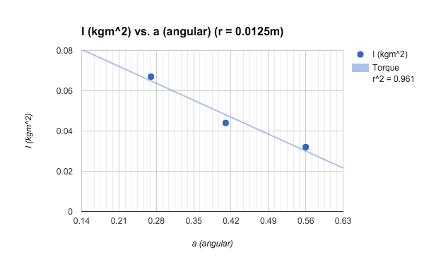

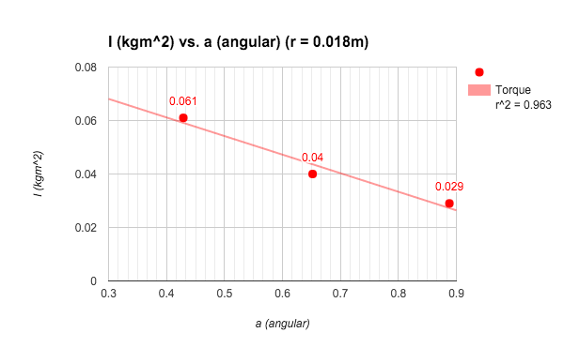

The graphs clearly show an inverse relationship between the angular acceleration and the moment of inertia. The torque in these trials was kept constant, and is seen in the slope of the graph.

**Discussion of Results**

Part 1:

The provided equations were used to calculate the moment of inertia, which turned out to be constant for the two trials regardless of the masses used. Although the moments of inertia varied slightly, the percentage was very low, therefore it can be assumed as they are constant.

Part 2:

In part 2, the values for the experiment were very accurate and netted a result that verified Newton’s second law of motion. An R value close to 1 showed that a linear trendline best described the correlation between the two values, and therefore shows their proportional relationship for first set of data, and the inverse proportional relationship for the second set of data.

There were several factors that could have caused errors in measurements, such as:

* Friction
* Accuracy of measurements
* Limited number of trials

**Conclusions**

The laws meant to be tested by this experiment were supported by actual data, which was very accurate and described the relationships very well. Therefore, the experiment was done correctly, albeit with small sources of error.

**Questions**

|  |  |  |  |
| --- | --- | --- | --- |
| **I(cm)** | **I(mass)** | **I(1+2)** | **I (Theoretical)** |
| 0.01 | 0.055 | 0.065 | 0.067 |
| 0.01 | 0.035 | 0.045 | 0.044 |
| 0.01 | 0.019 | 0.029 | 0.032 |
| 0.02 | 0.04 | 0.06 | 0.061 |
| 0.02 | 0.021 | 0.041 | 0.04 |
| 0.02 | 0.01 | 0.03 | 0.029 |

2). Friction cannot be ruled out, as some of the friction changes the force applied therefore it might not be possible to get the most accurate torque and inertia readings.

**References**

1. Physics 123 lab manual, Experiment 11. http://science.iit.edu/sites/science/files/elements/phy/pdfs/2013_lab_123_11.pdf